Strong Authentication with German eID Card reaches general public with Nextcloud and free https://eID.Services
[Michelau, 23 June 2021] ecsec GmbH developed the “eID-Login” App for Nextcloud on behalf of the Federal Office for Information Security (Bundesamt für Sicherheit in der Informationstechnik, BSI) and published it now under an Open Source License. This is the first time the German eID is integrated with a mainstream platform. Thanks to the SkIDentity service, which is provided without fee for the project, the German eID card can now be used free of charge for strong authentication in Nextcloud.
German eID Card can now be used in Nextcloud for strong authentication
The German eID Card (“Personalausweis”), which has been notified at the highest possible level of assurance (“high”) in accordance with the eIDAS-Regulation, can be used by all citizens for electronic identification (eID) and for strong pseudonymous authentication on the Internet. Until now, this has been used in a range of special applications mostly in the German government sector. With the “eID-Login” App for Nextcloud developed by ecsec GmbH on behalf of the Federal Office for Information Security (Bundesamt für Sicherheit in der Informationstechnik, BSI), it is now possible to use the German eID Card in the popular cloud solution for strong authentication.
Security by Design and Open Source guarantee highest level of trustworthiness
The early and consequent consideration of relevant security aspects according to the „Security by Design“ principle and the publication of the "eID-Login" App for Nextcloud as Open Source ensure that a very high level of trustworthiness is achieved. "It is great to see Nextcloud as the first mainstream platform with support for the German eID Card for strong authentication and identification," adds Frank Karlitschek, founder and managing director of Nextcloud GmbH. “We look forward to many users of this innovative authentication technology.”
Cooperation between BSI and ecsec GmbH enables free https://eID.Services
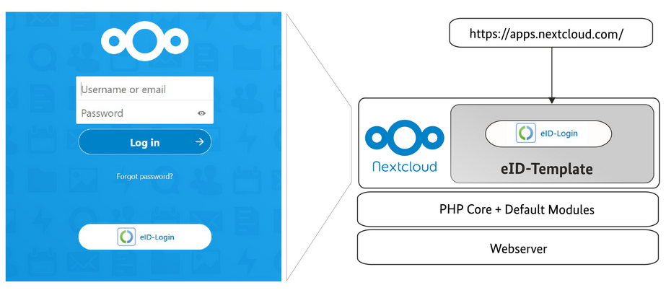
So that the German eID Card can be used immediately and free of charge for strong authentication in Nextcloud, the SkIDentity service, which has won multiple international awards, is also provided for strong authentication free of charge as part of the joint project. In addition to the free authentication service, the eID experts at ecsec GmbH also offer additional support services for hosting providers and application developers (see https://eID.Services) so that the "eID-Login" functionality can easily be integrated and used in other Open Source applications as well. "The provision of the eID-Login App for Nextcloud as Open Source is to be understood as a prelude and invitation to the community," adds Tina Hühnlein, founder and managing director of ecsec GmbH. "We are very confident that there will soon be more web applications with eID-Login."
Picture: eID_Login.jpg
Caption: eID-Login - simply log in with your German eID Card!

About ecsec GmbH
ecsec (https://ecsec.de/en) is a specialized vendor of innovative solutions in the sector of security in the information and communication technology, security management, smart card technology, identity management, web security and electronic signature technology. Based on experiences from several consulting projects with international reach ecsec GmbH counts to the leading providers in this sector and supports well known customers within the conception and implementation of tailor-made solutions. Due to the observance of current results of science and technology and current and future international standards, an excellent consulting quality and sustainable customer prosperity are guaranteed. For example, ecsec developed the Open eCard App and the Open eCard Library, which was the world's first Open Source "eID-Client" or "eID-Kernel" to be certified by the German Federal Office for Information Security and received numerous international awards for its innovative SkIDentity service, which enables "Mobile eID as a Service".

About Nextcloud
Nextcloud (https://nextcloud.com) offers the industry-leading open source software solution for on-premise data processing and communication. The platform combines universal data access via mobile, desktop and web interfaces with innovative, secure communication and collaboration functions such as document processing in real time, chat and video calls; and all of this under the direct control of IT and can be integrated into existing infrastructures. With its easy and fast deployment, modular architecture and focus on security and collaboration, Nextcloud enables modern companies to optimize their existing file storage facilities inside and outside the boundaries of their company.

Contact

Dr. Detlef Hühnlein  ecsec GmbH  Sudetenstraße 16  96247 Michelau  E-Mail: presse@ecsec.de  https://ecsec.de | Jos Poortvliet  Nextcloud GmbH  Head of Marketing  +49 1711217528  pr@nextcloud.com

